

Computer Networks 47 (2005) 47–61

www.elsevier.com/locate/comnet

Routing demands with time-varying bandwidth proﬁles
on a MPLS network

Fabio Ricciato *, Ugo Monaco

INFO-COM Dept., University ‘‘La Sapienza’’ of Rome, 00184 Rome, Italy
Received 19 November 2003; received in revised form 24 May 2004; accepted 11 July 2004
Available online 13 August 2004

Responsible Editor: H.-L. Truong

Abstract

In this work we consider the problem of routing bandwidth-guaranteed ﬂows with time-variable bandwidth proﬁles
on a MPLS network. We assume that each demand is routed in an explicitly routed LSP, and the amount of bandwidth
that must be reserved along the LSP varies during the day according to a piece-wise mask, which is known in advance.
The time-of-day bandwidth proﬁles can be explicitly declared by the VPN customers in the SLA, or alternatively pre-
dicted by the ISP based on past measurements.
In this framework, we propose a simple on-line algorithm for optimal selection of LSP paths. We also provide an
ILP formulation for the associated oﬀ-line problem, and adopt it as a reference performance bound for the on-line
algorithm.
Additionally, we compare the performances of ﬁxed and variable routing in presence of time-variable bandwidth pro-
ﬁles. The results presented here suggest that the a priori knowledge of the per-demand traﬃc proﬁles can be exploited to
achieve a ﬁxed routing conﬁguration, which can be marginally improved by variable reconﬁgurations. We relate our
ﬁndings with a couple of previous works that in diﬀerent application contexts achieved similar results.
2004 Elsevier B.V. All rights reserved.

Keywords: Network optimization; Simulations; MPLS; Routing

1. Introduction

In this work we consider the problem of routing

* Corresponding author. Tel.: +39 06 4782 5184; fax: +39 06
4893 0606.
E-mail addresses: fabio@infocom.uniroma1.it, ricciato@
coritel.it (F. Ricciato), monaco@infocom.uniroma1.it (U.
Monaco).
bandwidth-guaranteed ﬂows with time-variable
bandwidth proﬁles on a MPLS network. We as-
sume that each ﬂow (demand) is routed in a dedi-
cated label switched path (LSP), and that the

1389-1286/$ - see front matter 2004 Elsevier B.V. All rights reserved.
doi:10.1016/j.comnet.2004.07.012

48

F. Ricciato, U. Monaco / Computer Networks 47 (2005) 47–61

amount of bandwidth that must be reserved for a
LSP varies during the day according to a piece-
wise mask which is known in advance, denoted
as bandwidth proﬁle. The per-demand time-of-day
bandwidth proﬁles can be explicitly declared by
the customers and included in the service level
agreement (SLA) with the ISP. This would allow
the delivering of a more ﬂexible services, namely
the ‘‘time-varying virtual private networks’’ (tv-
VPN), aimed at better matching the customer
requirements in terms of bandwidth reservation
timing. With this approach, the customer require-
ment might resemble something like:

I want a pipe from site S to site D with assured 10
Mbps from 8:00 AM to 6:00 PM, with 5 Mbps
from 6:00 AM to 10:00 PM and only 1 Mbps from
10:00 PM to 8:00 AM.

On the customer side, the diﬃculty in estimat-
ing her/his bandwidth needs in the form of a
time-of-day vector is not far from that associated
to the estimate of a single bandwidth value, as is
done in current SLAs. On the operator side, the
possibility to distinguish the customer bandwidth
provisioning on a per-hour basis opens the way
to the introduction of diﬀerentiated billing models
(e.g., night-time connectivity cheaper). Such mod-
els have been extensively used in traditional circuit
switched telephone networks, and demonstrated
helpful to the operator to modulate the customer
behavior in order to optimize and distribute (in
time) the usage of the network infrastructure.
Alternatively, for non-VPN ﬂows (e.g., POP-to-
POP public traﬃc) the time-of-day traﬃc proﬁle
might be derived from past measurements. In fact,
it has been established that data traﬃc presents
high periodicity at the time-of-day scale (see for
instance [1] and reference therein, and [2]). There-
fore, it should be possible to predict the time-
of-day behavior of traﬃc demands based on past
measurements.
In all such cases (tv-VPN and predicted traﬃc)

allocated as they arrive, and there is no rearrange-
ment of previously allocated paths. In the latter,
the entire set of demands is known in advance
and all the routes are computed jointly in a global
optimization process. We also distinguish between
ﬁxed and variable routing, depending on whether
or not the route of each demand can be varied dur-
ing the time-of-day. Our interest is admittedly for
ﬁxed routing, and we will consider instances of
the variable routing problem in order to derive ref-
erence performance bounds. Incidentally, we
found that the optimal solution to the ﬁxed rout-
ing problem with complete knowledge of band-
width proﬁles holds about the same resources
usage than the optimal variable routing.
In this work we propose a simple on-line algo-
rithm for routing ﬁxed LSPs with declared time-
of-day bandwidth proﬁles. Our algorithm relies
on a simple shortest-path computation, where
the link weights are a function of the residual peak
bandwidth. This approach basically extends what
proposed in [3] for ﬁxed bandwidth demands. We
also provide integer linear programming (ILP) for-
mulations for the associated oﬀ-line problems, in
case of ﬁxed and variable routing, and solve them
to obtain reference performance bound for the on-
line algorithm.
The rationale behind this work is that the a pri-
ori knowledge of the per-demand time-of-day
bandwidth proﬁles can be exploited to minimize
the overall bandwidth reservation. In fact, by cou-
pling demands with increasing and decreasing pro-
ﬁles on a same link, it is possible to achieve a
certain degree of bandwidth saving. More for-
mally, by denoting with f^{k}(s) the amount of band-
width required by demand k at time s on a generic
link, a total amount of bandwidth equal to
max_{s}P_{k}f^{k}(s) is suﬃcient to support the bundle
of demands. On the other hand, in absence of
the exact knowledge of the full bandwidth proﬁle
but its peak, the reserved bandwidth would be
P_{k}max_{s}f^{k}(s).
The potential saving

the network has to route new LSPs taking into ac-
count their time-of-day bandwidth proﬁles, which
is known in advance. With respect to such routing
S ј
X

k
max f^{k}рsЮ max
s s
X
k
f^{k}рsЮ
р1Ю

problem, we distinguish the on-line and the oﬀ-line
problem instances. In the former, demands are
depends on several factors. First, as it comes from
the mutual compensation of increasing and

F. Ricciato, U. Monaco / Computer Networks 47 (2005) 47–61

49

decreasing bandwidth proﬁles, the saving is virtu-
ally null in case all demands have synchronized
peaks. In case of tv-VPN proﬁle, synchronization
can be counteracted by means of diﬀerentiated
billing proﬁles. Secondly, the potential bandwidth
saving depends on the routing algorithm and its
ability to ﬁt demands with mutually compensative
proﬁles on the same links. Our on-line routing
algorithm is speciﬁcally targeted to achieve this
goal.
In our model the per-demand bandwidth pro-
ﬁles are piece-wise constant, holding a certain
bandwidth value for a certain time interval. It
can be expected that some degree of discretization
in time would be beneﬁcial for a better ﬁtting of
compensative demands on the same links, and
consequently to increase the potential bandwidth
saving. Discretization in time means that the net-
work operator will deﬁne a common set of time-
of-day intervals (or ‘‘time slots’’) for all demands.
During the sth slot, the generic demand k is asso-
ciated to a single bandwidth value, say f^{k}(s). In
other words, the discretization in time enforces
the synchronization of changes in bandwidth res-
ervations at the time slot boundaries.
The rest of the paper is organized as follows. In
Section 2 we relate this work with the existing lit-
erature. In Section 3 we describe our on-line algo-
rithm for ﬁxed routing, while in Section 4 we
provide Integer Linear Programming (ILP) formu-
lations of the oﬀ-line problem instances, both for
ﬁxed and variable routing. In Section 5 we provide
several numerical results assessing the goodness of
the on-line algorithm, included a comparison with
reference bounds as provided by the solution of
the of-line optimization instances. In Section 6
we relate our results on ﬁxed and variable routing
with those found in two previous works, namely
[4,5]. Finally, in Section 7 we conclude and suggest
new directions for further research.

2. Relation to previous work

The literature on routing in connection-oriented
packet networks, basically ATM and MPLS, is ex-
tremely vast. The problem of on-line routing of
guaranteed-bandwidth virtual circuits has been

faced in a large number of previous works, for in-
stance [3,6–8] to cite only few samples. Quite sur-
prisingly, none of them ever considered the case
of traﬃc demands with time-varying bandwidth
proﬁle.
To the best of our knowledge, the problem of
optimal network conﬁguration in presence of
known time-varying traﬃc only appeared in [4,5].
Both works where in the perspective of oﬀ-line
conﬁguration, i.e. global optimization, while in
this paper we are mainly interested in the on-line
problem. The application contexts were also very
diﬀerent from the one considered here: a connec-
tion-less network with OSPF/IS-IS routing in [4],
and a connection-oriented multi-layer network in
[5]. Despite the considerable diﬀerences in the ap-
proach and in the application scenario, we believe
there is a common fundamental relationship be-
tween our ﬁndings and the experimental results re-
ported in that previous works. Section 6 in this
paper is devoted to enlighten such commonalities
and suggest a broader direction for further
research.
Under the algorithmic perspective the present
work has a certain relationship with [3]. In fact,
it was the ﬁrst one to suggest the shortest-path
routing with link-weights dependent on the resid-
ual-bandwidth (let us denote this approach as
residual inﬂuenced shortest-path, RISP). Basically,
the on-line heuristic proposed in Section 3 is an
extension of the RISP approach, where the resid-
ual bandwidth becomes a vector in s but the
link-weight remains a scalar.
One might wonder why we preferred RISP to
alternative approaches, for example MIRA [7]
and its derivations [8]. We believe that the main
attractiveness of the RISP scheme is in its extreme
simplicity, so that it can be easily extended to be
applied to more articulated problems. For in-
stance, in a previous work [9,10] we adopted a
RISP-like scheme for the on-line routing of pro-
tected demands against single and dual faults. As
a further step, we are currently working to incor-
porate the time-varying extensions of RISP into
that scheme, so as to achieve a global model for
the on-line allocation of protected demands with
time-variable bandwidth proﬁles. At the same
time, we believe that the extension of a MIRA-like

50

F. Ricciato, U. Monaco / Computer Networks 47 (2005) 47–61

model to the case of time-varying traﬃc demands
is an interesting topic for future research.

3. Proposed on-line algorithm

We consider the 24 h day-time partitioned into
a total of H time slots, not necessarily of equal
duration. The index s = 1, 2,. . ., H will denote
the generic time slot, while the indices k and m
will refer to demands and links respectively. We
assume that connection requests (i.e. demands)
arrive randomly to the network. The generic
kth demand is associated to a ingress–egress node
pair (s^{k}, d^{k}) and to a bandwidth-proﬁle vector de-
noted by { f^{k}(s), s = 1, 2, . . ., H}, being f^{k}(s) the
amount of bandwidth required by the kth de-
mand during the time slot s. Let us introduce
the notation that will be used throughout the rest
of the paper:

• r^{k}m is the fraction of traﬃc from the kth demand

to the RSE, collecting the topology information as
well as the full proﬁle of reserved bandwidth
{u_{m}(s), s = 1, 2,. . ., H} for each network link. In
case of distributed implementation, the link band-
width proﬁles can be disseminated by appropriate
extensions to existing ﬂooding protocols (e.g.,
OSPF-TE [11]). It is not in the scope of this paper
to compare the centralized versus distributed
implementation of on-line routing, and the inter-
ested reader is referred for instance to [12,10] for
more material on this issue. For each new request,
the RSE prunes from the network topology graph
those links without enough available bandwidth to
accommodate the request, i.e. those for which
f^{k}(s) + u_{m}(s) P C_{m}for some s. In a second step,
it assigns a link cost w_{m}to each link m as a non-
decreasing function of
x_{m}ј max f^{k}рsЮ ю u_{m}рsЮ ; р2Ю
sј1;2;...;H
for example,
C_{m}

that is routed over link m р0 6 r^{k}m⁶1Ю.
• u_{m}(s) is the amount of bandwidth reserved on
w_{m}ј
C_{m}x_{m}
ю :
р3Ю

link m during the time slot s.
• v_{m}= max_{s}=1,. . .,H{u_{m}(s)} is the peak link band-
width on link m, i.e. the maximum amount of
bandwidth reserved across the entire day-time.
Unless diﬀerently speciﬁed, we will assume that
the peak bandwidth is the relevant metric
accounting for link resource usage, so that occa-
sionally v_{m}will be simply referred to as link
bandwidth.
• C_{m}is the capacity of link m.
• w_{m}is the link-weight associated to link m. Its
value is dynamically computed for each new
request according to the proﬁles of reserved
and requested bandwidth.

The generic kth request arrives at the route
selection engine (RSE), which computes the most
convenient route between the ingress–egress pair
(s^{k}, d^{k}). We assume that the new demand will be
routed without rearranging the already established
ones. The RSE can be either duplicated in each
edge-node, like in the distributed MPLS-TE archi-
tecture, or centralized in a single route server. In
both cases, we assume that a database is available
Note¹that w_{m}< 1 because of the previous
pruning. We tried several alternative weight
functions (see Table 1). The numerical results
showed that in the considered sample scenarios
the function (3) holds the better performances.
Based on the link weight w_{m}, the RSE produces
a weighted directed graph, and on that it runs
Dijkstra to ﬁnd the minimum cost path between
the assigned ingress–egress pair for the new
demand.
This scheme is basically an extension of RISP,
and it is well suited to incorporate some additional
features that are of great importance in real net-
works. For instance it is easy to incorporate mul-

1 The random term e 1 has a marginal role, namely to
scramble the route selection for parallel demands (i.e. with same
ingress–egress pair) in case of a poorly loaded network. In fact,
in this case a large number of network links have null reserved
bandwidth, resulting in a quasi-uniform link-weight assign-
ment. If multiple paths of equal hop-length exist between a
given ingress–egress pair, the addition of a small randomization
in the link-weight prevents from preferential selection of the
same path for parallel demands.

Table 1

F. Ricciato, U. Monaco / Computer Networks 47 (2005) 47–61

51

Comparison between link-weight functions for the on-line algorithm: mean values of b_{n}over 500 trials (std. dev. in brackets)

Link-weight function
14-nodes net. (NSFnet)
30-nodes net.
15-nodes net. (MIRA)

b₁
b₁₀
b₁₀₀
b₁
b₁₀
b₁₀₀
b₁
b₁₀
b₁₀₀

A
w_{m}ј C_{m}=рC_{m}x_{m}Ю
629.69 664.32 742.74
1106 1160.8 1303.9 991.94 1060.3 1181.6

B
(33.3) (29.9) (22.5) (55.4) (50.7) (35.2) (58.3) (45.2) (29.6)
w_{m}ј expрC_{m}Ю=рC_{m}x_{m}Ю 640.2 671.07 746.69 1181 1235.2 1371.7 1035.9 1095.8 1195.2
(28.4) (27.1) (22.5) (51.8) (48.6) (30.8) (52.1) (39.6) (28.2)

C
w_{m}= 1
598.96 631.9 719.94 1097.7 1148.2 1278.2 951.93
1024 1147.7

D

E

w_{m}ј x_{m}=C_{m}

w_{m}ј expрx_{m}=C_{m}Ю
(31.6) (29.3) (22.4) (51.8) (47.5) (32.1) (55.4) (40.9) (27.9)
622.23 654.55 738.6 1116.2 1161.8 1296 981.74 1049.6 1178.4
(31.3) (28.2) (23.3) (54.8) (51.2) (34.4) (57.1) (44.3) (30.9)
617.67 649.77 735.64 1108.6 1156.7 1291.9 962.79 1042.3 1176.7
(30.2) (28.1) (21.7) (54) (51.8) (34.4) (58.8) (46) (29.8)

WS Widest-shortest path
591.58 626.22 714.77 1100.4 1148.7 1283.2 935.67 1011.2 1139.8

(32.4) (28.9) (24.4) (54.4)
(49) (32.6)
(58) (43.1) (30.1)

SW Shortest-widest path
521.56 543.58 593.44 1009.1
1045 1108.3 874.73 913.04
979

(21.7) (20.8)
(20) (35.5) (30.3)
(30) (33.6) (27.9) (25.9)

tiple-destination demands, as found for example in
the routing of inter-AS ﬂows, where usually more
than one border routers are candidate egress
points for the same ﬂow. This case can be handled
with very simple graph transformations. Addition-
ally, if a pair of disjoint paths have to be allocated
for some demand in order to apply end-to-end
path protection, the Dijkstra algorithm can be re-
placed by the Suurballe algorithm that returns the
shortest-pair of disjoint paths (see [9,10]). Such
possibilities enrich the attractiveness of the pro-
posed model, but have been left out of the scope
of this paper.

4. ILP formulation

The allocation mechanism described above is
heuristic, and there is no assurance that it is eﬀec-
tive in optimally ﬁtting the bandwidth proﬁle of
the new request {f^{k}(s), s = 1, 2,. . ., H} with the
existing proﬁles of reserved bandwidth on the links
{u_{m}(s),s = 1, 2,. . ., H}. In order to evaluate the
goodness of our approach, we need to consider a
performance metric and compare with a reference
performance bound. To this purpose, we consider
a integer linear programming (ILP) formulation to

the problem of allocating a given set of demands
with assigned time-varying bandwidth proﬁles in
a capacitated network, with the general objective
of minimizing the peak reserved bandwidth v_{m}
on the network links.
We will consider MIN–MAX, MIN–MEAN
and mixed optimization objectives: the factor
0 6 a 6 1 in the objective function to be mini-
mized can be varied to trade-oﬀ between these
concurrent objectives. We preferred this approach
instead of deﬁning a convex cost function as done
in some previous works, e.g., [4,5]. With the con-
vex-cost approach, one applies an increasing pen-
alty on the link load, and in our case, we do not
need to introduce such a penalty. In fact, we use
ILP to solve the oﬀ-line instance of the routing
problem, therefore assuming full knowledge of
the set of demands under optimization, and no
penalty is needed to defer the emergence of
bottlenecks.
The optimization problem can be formulated as
follows:²

2 The notation ‘‘m ! n’’ (resp. ‘‘m n’’) identiﬁes the set of
directed links m that have node n as source (resp. destination).

52

Minimize

F. Ricciato, U. Monaco / Computer Networks 47 (2005) 47–61

The routing model expressed by the above for-
mulation, as well as of the heuristic on-line algo-

c ј a c_{max}ю р1 aЮ cmean
Subject to
X X
rithm, is an example of ﬁxed routing, in that each
demand route is ﬁxed in time. In fact, a single rout-
ing variable r^{k}m is deﬁned across the full set of time-

m!sk
X
r^{k}m^{ј}1;

r^{k}
m^{ј}0;
m sk
X
r^{k}m^{ј}0 8k;

r^{k}m^{ј}1 8k;
р4aЮ

р4bЮ
slots. In our work we were interested in evaluating
the potential gain in bandwidth saving that can be
achieved by a variable routing model, where the

m!d^{k}
X
r^{k}
X
m d^{k}
r^{k}

k
route of each demand is allowed to change from
time-slot to time-slot. The ILP formulation for

m!n
m
m n
X
m^{ј}0 8k; n 6ј s ; d^{k};
р4cЮ
the variable routing problem with time-varying de-
mands only requires a minor adaptation to the

u_{m}рsЮ ј

k
f^{k}рsЮ r^{k}m⁸m; s;
р5Ю
above formulation: the substitution of the routing
variables r^{k}m with r^{k}m^{р}sЮ, and the replacing of con-
straints (4) and (5) with the following ones:

v_{m}P u_{m}рsЮ 8m; s;
v_{m}6 C_{m}8m;
1
c_{max}P v_{m}8m;
C_{m}
р6Ю
р7Ю

р8Ю
X
m!sk
X
m!d^{k}
r^{k}m^{р}sЮ ј 1;

r^{k}
m^{р}sЮ ј 0;
X

m d^{k}
X

m d^{k}
r^{k}m^{р}sЮ ј 0 8k; s;

r^{k}m^{р}sЮ ј 1 8k; s;

р11aЮ

р11bЮ

cmean^{ј}
1
M
X^{M}
mј1
1
C_{m}
v_{m};
р9Ю
X
m!n

r^{k}m^{р}sЮ
X

m n

k
r^{k}m^{р}sЮ ј 0 8k; s; n 6ј s ; d^{k}; р11cЮ

r^{k}m^{2 f}0; 1g 8k; m:
р10Ю

u_{m}рsЮ ј
X

f^{k}рsЮ r^{k}m^{р}sЮ 8m; s:

р12Ю

Constraints (4) are classical network ﬂows con-
straints. In particular (4a) and (4b) refer to the de-
mand ingress and egress nodes respectively, while
(4c) to the remaining intermediate nodes. Eq. (5)
deﬁnes the reserved bandwidth on link m for each
time slot. Eq. (6) deﬁnes the peak level of band-
width reservation on link m. Eq. (7) enforces the
capacity constraint. Finally, Eqs. (8) and (9) deﬁne
respectively the maximum and mean value of link
load, which are the two terms in the cost function
to be minimized.
The above ILP formulation has the same struc-
ture of a classical multicommodity-ﬂows formula-
tion (Ref. [13]). The only variant is that the
demand size and the associated constraints are de-
ﬁned for each time slot. This formulation can not
be resolved for the considered network under test
with a large number of demands (in the order of
10³). Its integer relaxation with continuous routing
variables 0 6 r^{k}m^{р}sЮ 6 1 will be used in Section 5.3
to provide a performance bound to the oﬀ-line
routing problem, hence to the on-line heuristic
algorithm described in Section 3.
k
In practice, the implementation of variable rout-
ing would add complexity and overhead to the net-
work architecture, and the global rearrangement of
demand routes at each time-slot boundary is some-
thing that any ISP would dislike. Therefore, the
variable routing model is not attractive unless the
cost of the additional complexity is payed-oﬀ by a
sensible resource saving. The comparison between
the bandwidth consumption with the ﬁxed and var-
iable routing formulations, given in Section 5.4,
provides a helpful insight into this issue.

5. Numerical results

We implemented in an ad-hoc simulator the on-
line routing mechanism described in Section 3. The
ILP instances were implemented in AMPL [14]
and solved with CPLEX [15]. We run a number
of simulations targeted at investigating the follow-
ing topics:

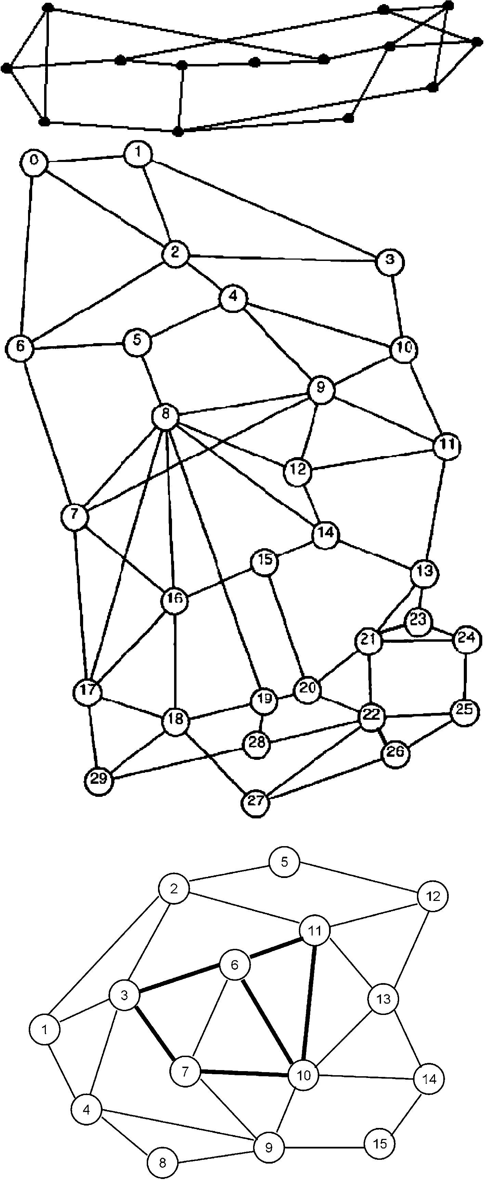

F. Ricciato, U. Monaco / Computer Networks 47 (2005) 47–61

• Impact of the choice of link-weight function on
the on-line algorithm performances.
• Allocation eﬃciency of the on-line algorithm
compared to the relaxed oﬀ-line problem
instance.
• Comparison between variable and ﬁxed
routing.
• Impact of time-slot granularity.

All the experiments were run on three test top-
ologies, shown top-down in Fig. 1. The ﬁrst one
(14 nodes, 21 links) is the celebrated NSFnet
topology which has been extensively considered
in several previous works in routing. The second
one (30 nodes, 61 links) is the same used in [16],
with the arbitrary addition of two links to raise
the node degree to 3. The third one (15 nodes, 28
links) is the MIRA topology considered in [7]. In
the ﬁrst two cases all links have the same capacity
(denote by C), while in the MIRA network the
capacity of the internal links (bold line in the ﬁg-
ure) is three times that of the remaining ones, i.e.
3C.
We considered the following performance
metrics:

• The mean and maximum values of the peak link
bandwidth across all the network link, denoted
by cmean^{and}c_{max}, respectively.
• The maximum number of allocated demands
before the 1st, the 10th and the 100th rejection,
denoted respectively by b₁, b₁₀and b₁₀₀.

Given that all demands have identical average
proﬁles, it is meaningful to consider the number

53

of allocated demands as a metric for network load.
In this perspective b₁is taken as the boundary indi-
cator of the non-saturated region, that constitutes
the network operational region in the practical
cases. Instead, b₁₀and b₁₀₀are taken as indicators
of the quasi-saturated and fully saturated region
boundaries.

5.1. Traﬃc model

We considered a random arrival process of con-
nection requests to the network. For each ingress–
egress pair (i, j) demands arrive according to a
Fig. 1. Test networks.

Poisson process of intensity k_{ij}. We adopted a ﬂat
spatial distribution of traﬃc intensities, i.e. k_{ij}= k,
" i, j.
For each demand k, its bandwidth proﬁle is
built randomly by extracting H independent sam-
ples, one for each time slot, out of the discrete
set of bandwidth units {0, 1, . . ., 5}. In case of null
proﬁle (all 0s) the extraction is repeated. The basic
link capacity C is set to 125 units in each direction.
By considering a bandwidth unit of 20 Mbps, this

54

F. Ricciato, U. Monaco / Computer Networks 47 (2005) 47–61

correspond to a link capacity C = 2.5 Gbps, with a
maximum requested bandwidth of 100 Mbps.
The demand duration is inﬁnite, so that after a
certain number of demands have been allocated the
network approaches saturation and starts to reject
new requests. In the following we will denote a sam-
ple sequence of requests as an ‘‘input trace’’. When
comparing diﬀerent routing schemes, we run parallel
experiments with exactly the same input traces.
The traﬃc model adopted in this work is admit-
tedly arbitrary and very simple. It does not pretend
in any way to be representative of real traﬃc distri-
bution in space nor in time. The synthesis of a con-
vincingly representative traﬃc model is still an
open point for research, despite the recent consid-
erable achievements towards the comprehension
of real traﬃc dynamics (see for example [1,17]).
In any case, such model can not be independent
from the underlying topology structure, given that
in most cases the topology building process follows
the evolution of the traﬃc distribution. Perhaps, in
force of such intimate correlation, the research
community should pursue the deﬁnition of a un-
ique topology/traﬃc model. So far, there is no
established and widely accepted model for traﬃc
generation at the macroscopic scale. Therefore, in
our study we had to arbitrary choose a traﬃc mod-
el, and we gave preference on purpose to one that is
as ‘‘neutral’’ as possible: ﬂat spatial distribution
(k_{ij}= k) and bandwidth samples uncorrelated in
time. Moreover, having in mind that the direct
application of such algorithm is to support the
delivery of tv-VPN services, an additional obstacle
to the adoption of a realistic model of bandwidth
proﬁles is the fact such service have not been de-
ployed to date. The replication of this study with
diﬀerent topology/traﬃc models will be itself an
interesting direction for further research.

5.2. Choice of the link-weight function

In a ﬁrst set of simulations we investigated the
impact of the link-weight function on the perform-
ances of the on-line routing algorithm. We consid-
ered several diﬀerent types of function, among the
others the sample set given in Table 1. They were
selected arbitrarily since in the end the proposed
on-line scheme is heuristic. Additionally, we also

considered shortest-widest (SW) and widest-short-
est (WS) optimization criteria introduced in
[18,6,19] respectively. For each of them, we run
500 simulations and reported in the table the mean
number b_{n}of allocated demands before the nth
blocked request, with n = 1, 10, 100. In particular,
the value of b₁directly expresses the capacity of
the on-line routing algorithm to ﬁll the network
before that service degradation appears in the
form of request blocking.
Beyond such metrics, it is also important to con-
sider the ability of the on-line routing scheme to
save network resources, i.e. bandwidth. In Fig. 2
we plot the values of c_{max}and cmean after each allo-
cated demand for a sample input trace, until b₁. The
general objectives of minimizing bandwidth usage
and maximizing demand allocation are not in con-
trast. Instead, the minimization of mean and maxi-
mum link bandwidth are often in contrast. In fact, a
preferential selection of shorter paths tends to min-
imize cmean at the cost of a potentially larger c_{max}.
On the contrary the preferential minimization of
c_{max}pushes towards longer detours.
Our results show that the link-weight function
‘‘A’’ and ‘‘B’’ produce the best performances.
The allocation capacity of ‘‘A’’ and ‘‘B’’ is always
higher than the other functions (b₁in Table 1),
with a lower c_{max}in the full range of demands
(Fig. 2, top). They also show better allocation
capacity than WS and SW. The function ‘‘B’’
allocates more demands than ‘‘A’’ (from approxi-
mately +2% in the 14-nodes to +7% in the
30-nodes network), while keeping a lower c_{max}at
the cost of a higher cmean. This means that function
‘‘B’’ tends to produce longer paths than ‘‘A’’. Be-
tween ‘‘A’’ and ‘‘B’’ we give preference to the
former, as we believe it is a good compromise
between allocation power (high b₁) and global
bandwidth usage (low cmean), and unless diﬀerently
speciﬁed in the rest of this paper we will adopt it in
the on-line algorithm. We recognize that such pref-
erence might appears like ‘‘a matter of taste’’, on
the other hand there is no objective metric telling
how much an operator is accepting to trade path
lengths for allocation power, the decision being
driven by external factors (e.g., the policy of link
resizing). We remark that in general it is not diﬃ-
cult to tailor the on-line algorithm to the speciﬁc

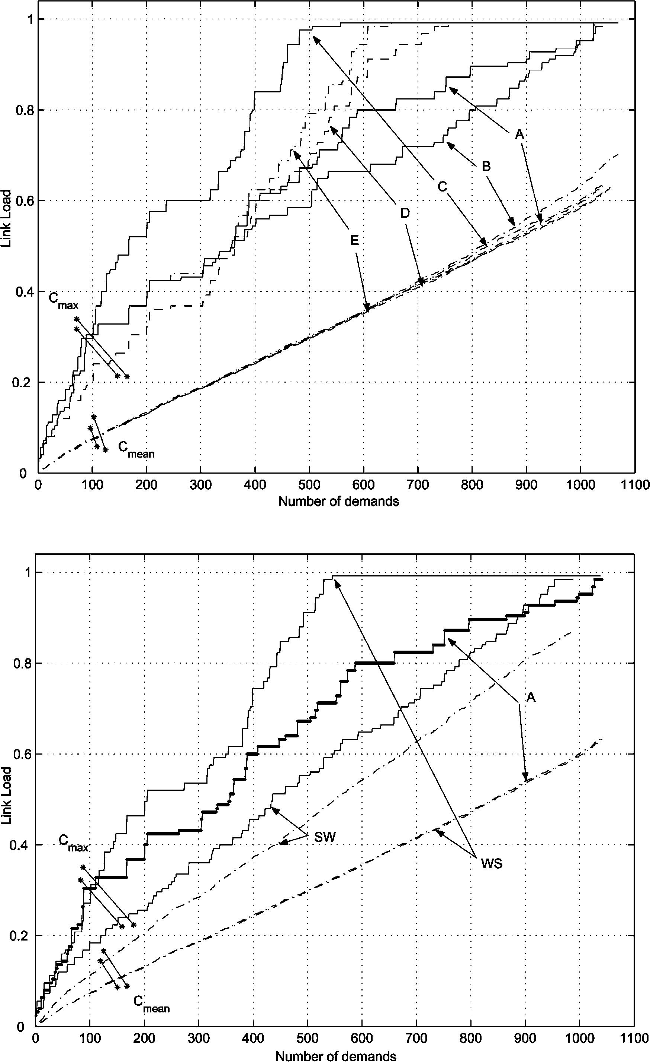
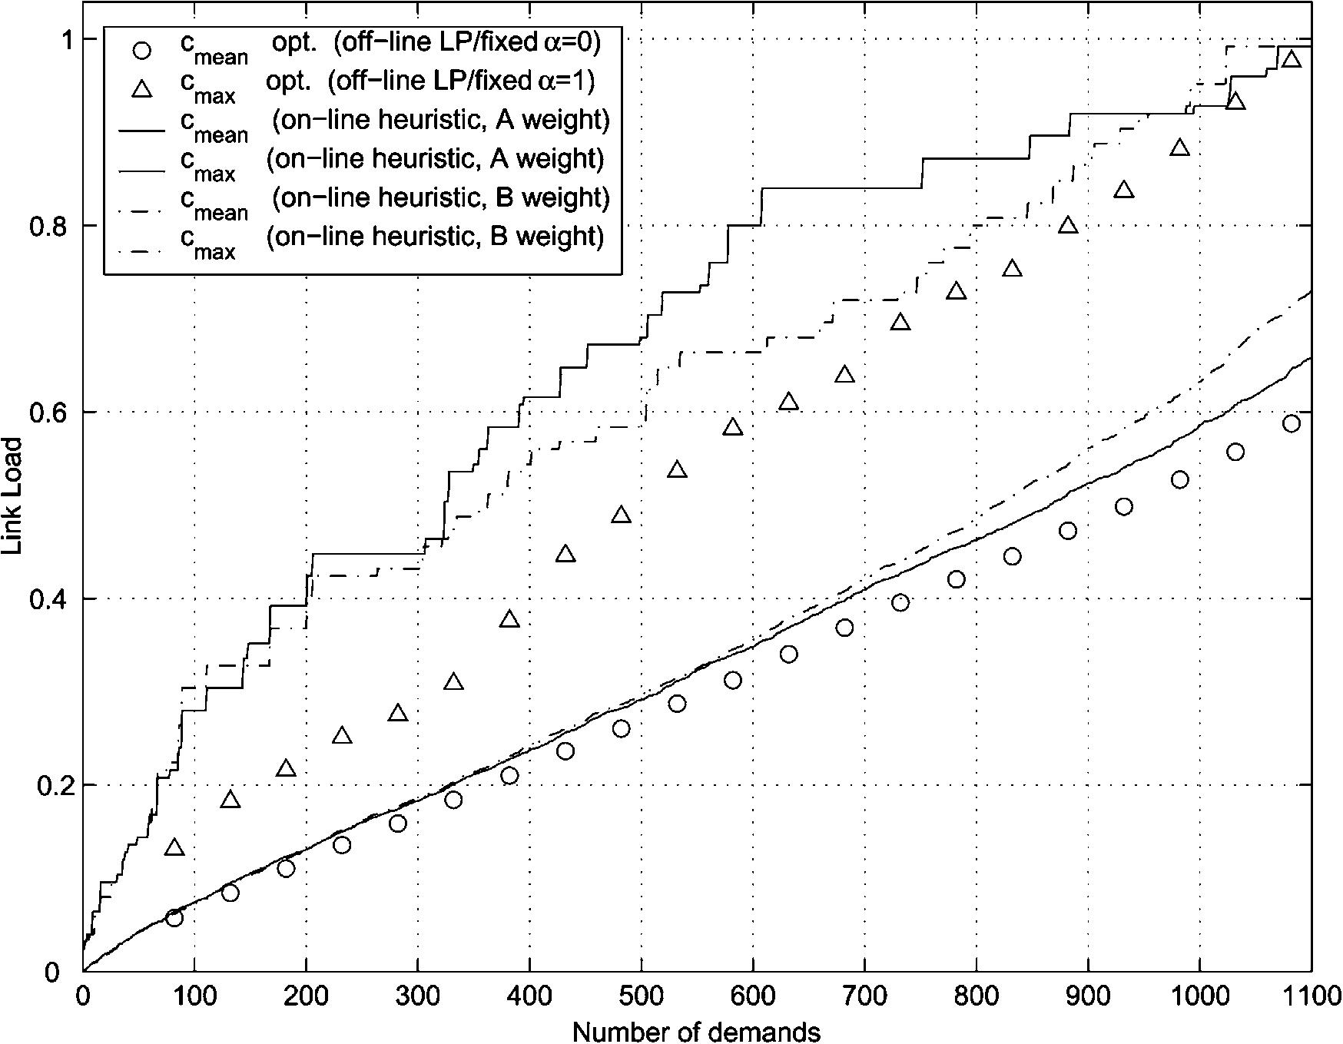

F. Ricciato, U. Monaco / Computer Networks 47 (2005) 47–61

55

Fig. 2. Comparison between cmean^{and}c_{max}for diﬀerent link-
weight functions for a sample input trace.

preferences of a network operator, for example by
including additional constraints on the maximum
path length, or a very high penalty for exceeding
some link bandwidth watermarks, etc. It is out of
the scope of a research paper to elaborate the de-
tails and possibilities of such ‘‘customization’’
process. Rather, we are interested in providing a
proof-of-concept that the basic underlying algo-
rithm is eﬃcient, and simple enough to be adapted
to a broad range of practical scenarios.

5.3. Comparison with LP oﬀ-line

After tuned the on-line algorithm with the
choice of a suitable link-weight function, we were

interested in evaluating the goodness of our on-
line algorithm with respect to a provable bound.
To this purpose, in Section 4 we developed an
ILP formulation to the problem of allocating a gi-
ven set of demands with time-varying traﬃc proﬁle
in a capacitated network (oﬀ-line problem). We
solved its integer relaxation, by letting the routing
variables be continuous in 0 6 r^{k}m^{р}sЮ 6 1. This cor-
responds to the possibility of arbitrary multipath
routing (also called ‘‘splittable traﬃc’’ in [7]).
Therefore the values of cmean^{and}c_{max}referred to
the oﬀ-line instance must be considered as lower
bounds to the optimal values for the case of sin-
gle-path routing (i.e. non-splittable traﬃc).
In Fig. 3 we reported the cmean^{and}c_{max}curves
as obtained with the on-line algorithm for a sam-
ple input trace. Both the cases of ‘‘A’’ and ‘‘B’’
weight function are plotted, and compared with
the optimal values obtained by solving the oﬀ-line
problem instance with the relaxed LP formulation,
for diﬀerent number of demands. More precisely,
the optimal values of cmean (circles in Fig. 3) were
obtained by solving the MIN–MEAN form of the
LP/oﬀ-line problem, i.e. with a = 0 in the objective
function. Conversely, the optimal values of c_{max}
(triangles) were obtained by solving the MIN–
MAX problem (a = 0.99). We also tried with inter-
mediate values of 0.01 < a < 0.99, and we found

Fig. 3. Comparison between mean and max bandwidth usage
with the on-line algorithm (‘‘A’’ and ‘‘B’’ weight functions) and
the optimal values obtained with the oﬀ-line relaxed problem
instance.

56

F. Ricciato, U. Monaco / Computer Networks 47 (2005) 47–61

that in all cases the output values of cmean^{and}c_{max}
were extremely close to that reported in Fig. 3. In
other words, the quality of the solutions with re-
spect to the dual metric cmean^{and}c_{max}was quite
robust to changes in the coeﬃcient of the objective
function. Interestingly, a similar result was re-
ported in [4] with a completely diﬀerent cost func-
tion (convex piece-wise linear). From Fig. 3 it can
be seen that the on-line algorithm achieves a mean
peak bandwidth reservation which is very close to
the optimum, especially in case of ‘‘A’’ link-weight
function. The distance from the optimal cmean^{is}
negligible when the load is low (until 700 de-
mands). After this point, the on-line algorithm
with the ‘‘B’’ function produces higher cmean, while
with the ‘‘A’’ function it follows more closely the
optimality. In any case, the deviation from the
optimality is of few percentage points.
Regarding the maximum peak bandwidth c_{max},
the on-line algorithm leads to larger values than
the optimal for light load. We remark that a part
of this gap is to be accounted to the LP relaxation
of the oﬀ-line instance, in addition to the sequen-
tial nature of the on-line algorithm. However, such
a gap is not a major concern since in this region
the peak link bandwidth is far away from saturat-
ing the link capacity, therefore the risk of emerging
bottleneck links that could potentially block new
demands is still negligible. On the other hand,
when the network load augments, the on-line algo-
rithm assigns higher link weights to heavy-loaded
links, so that the growth of c_{max}slows and its val-
ues get closer to the optimal ones. The conver-
gence of c_{max}towards the optimum occurs earlier
for the ‘‘B’’ link-weight function, but at the cost
of a slightly larger cmean: this clearly indicates a
stronger preference for longer but less loaded
paths.
The above results globally show that the alloca-
tion behavior of the on-line algorithm is within few
percentage points from the optimality with respect
to mean and total bandwidth usage, with accepta-
ble performances in terms of maximum link load.
Our conclusion is that the proposed on-line
scheme, still very simple, can be regarded as highly
eﬃcient. This lets strict margins of further
improvement. Hence, it seems there is little room
for further reﬁnements and/or additions to the

algorithm which are likely to come along with an
increase in system complexity and/or reduced sca-
lability, unlikely to be payed-oﬀ by few percentage
points of performance improvement.

5.4. Fixed versus variable routing

The on-line routing scheme proposed in Section
3 couples time-variable bandwidth reservations
with ﬁxed routing. In fact, the amount of band-
width reserved by a generic LSP on a link follows
a time-varying proﬁle, but the LSP route is ﬁxed in
time and does not change.
Removing the ﬁxed routing constraint would
mean to allow the demand route to change from
time-slot to time-slot. This would add more ﬂexi-
bility to the allocation model, and potentially im-
prove the global bandwidth saving by allowing
the route conﬁguration to adapt to the speciﬁc
traﬃc distribution in each time-slot, irrespective
of what happens in the others. We will refer to
such scheme as variable routing, as opposite to
ﬁxed routing. The main drawback of variable rout-
ing is that any such scheme would require addi-
tional network capabilities and fatally add
complexity to the network protocols, for instance
on the control plane.
In our investigations we were interested in eval-
uating the potential bandwidth saving of variable
routing versus ﬁxed routing, in the context of
time-varying bandwidth proﬁles. To this purpose,
we derived in Section 4 an ILP formulation for
the associated oﬀ-line problem: given a set of de-
mands and associated bandwidth proﬁles, ﬁnd
the best set of routes (one for each time-slot) for
each demand. Again, the objective function to be
minimized was the peak link bandwidth, through
the metrics cmean^{and}c_{max}, and there was no pen-
alty for route changes.
We solved the relaxed oﬀ-line instances of vari-
able and ﬁxed routing for the same set of input
traces, for diﬀerent number of demands, for both
the considered topologies, and with diﬀerent val-
ues of a. Quite unexpectedly, in all cases the dis-
tance between the values of cmean^{and}c_{max}
obtained with variable and ﬁxed routing was extre-
mely close, and in most cases indeed negligible. In
order to get a deeper insight into the phenomenon,

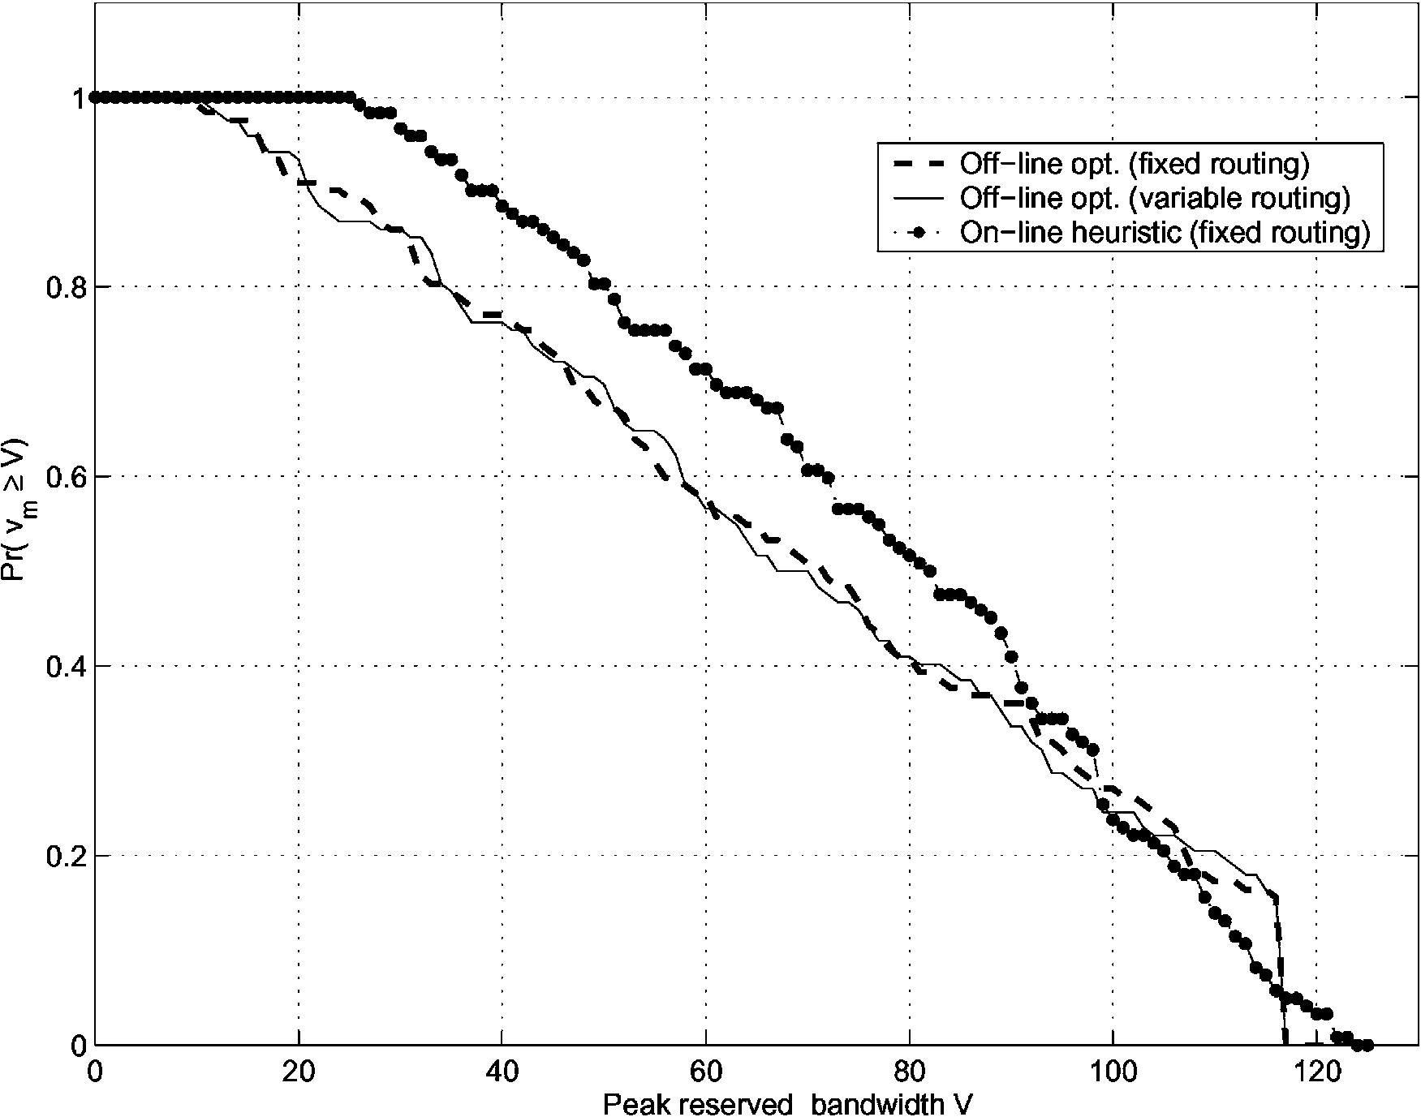

F. Ricciato, U. Monaco / Computer Networks 47 (2005) 47–61

57

we plotted in Fig. 4 the full cumulative distribution
function (CDF) of the peak link load over all the
network links, obtained with the variable and ﬁxed
routing versions of the oﬀ-line problem with
relaxed routing variables and a = 0.1, on the
30-nodes network and for a total of 1030 demands.
It can be seen that the two distributions are
very close to each other. In Fig. 4 we also
reported the CDF obtained by the on-line algo-
rithm (with the ‘‘A’’ function), loaded with a
sequence of the same set of demands. Again, the
closeness of this curve to the others constitutes a
further conﬁrmation of the eﬀectiveness of our
on-line algorithm.
Similar results hold for the 14-nodes network.
In that case, we veriﬁed for a sample input trace
that the relaxed oﬀ-line problem becomes unfeasi-
ble after 650 demands, both with ﬁxed and varia-
ble routing, while the on-line algorithm accepted
635 demands before the ﬁrst rejection, i.e. only
2%. Such results globally show that the optimal
solution obtained with relaxed (splittable) variable
routing holds the same bandwidth usage than re-
laxed ﬁxed routing. In other words, the ﬁxed rout-
ing constraint has a marginal impact on the quality
of the optimal solution.
This conclusion could seem counterintuitive. In
fact, it is easy to provide simple counterexam-

Fig. 4. CDF of the peak link load after 1030 demands (30-
nodes network). Comparison between optimal solution with
variable/ﬁxed routing (relaxed LP with a = 0.1) and on-line
algorithm.

ples—small graphs with a small number of de-
mands—where the gap between ﬁxed and
variable routing is considerable. On the other
hand, in networks with a large size and/or a large
number of demands the statistical impact of such
pathological cases is likely small. Admittedly, a
similar explication was reported by Fortz and
Thorup [4]. We believe that this argument might
explicate not only the closeness of the optimal val-
ues for ﬁxed and variable routing, but also the
closeness of our on-line algorithm to the
optimality.
Our ﬁndings are consistent with the results
found independently by Fortz and Thorup [4]
and by the same authors [5] in other application
contexts. A comparative discussion between the
three works is given in Section 6.

5.5. Impact of time-slot granularity

In the above sections we showed that the pro-
posed on-line algorithm is eﬀective in exploiting
the a priori knowledge of bandwidth proﬁles to
minimize the overall bandwidth usage. In this sec-
tion, we are interested in evaluating the gain
achievable by the proposed scheme versus the tra-
ditional reservation strategy, which assumes
knowledge of the peak bandwidth only. At the
same time, we are interested in assessing the
dependence of such gain with respect to the gran-
ularity of the time-discretization, i.e. the number
of time-slots H.
In the traditional reservation scheme (hereafter
referred to as ‘‘peak-based’’) the demand size is
represented by a single value, namely the peak re-
quested bandwidth f_{k}ј max_{s}ј1;...;H^{f}f^{k}рsЮg.
Hence, the bandwidth reserved on each link is also
a scalar, and will be denoted as v_{m}. Instead, in our
scheme both the demand size and the link reserved
bandwidth are vectors of size H in the time-slot in-
dex s.
To compare the two schemes, we implemented a
‘‘peak-based’’ on-line algorithm that reserves an
amount of bandwidth equal to f^{k}for each demand
along its path and for the entire day-time. The
route selection is similar to that described in Sec-
tion 3, with a link-weight function that is inversely
proportional to the residual bandwidth (‘‘A’’

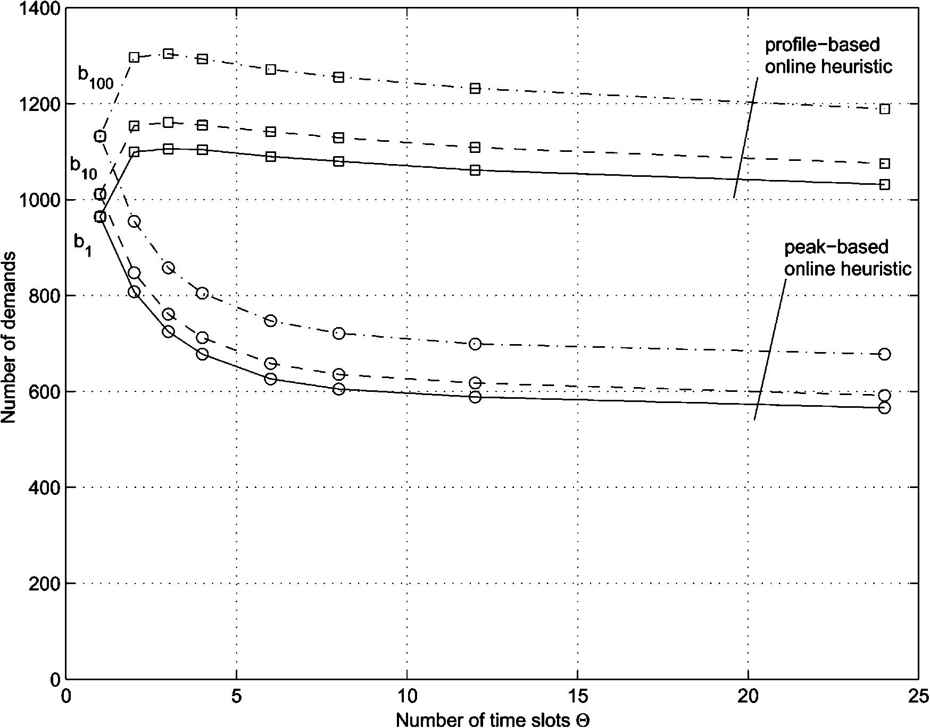
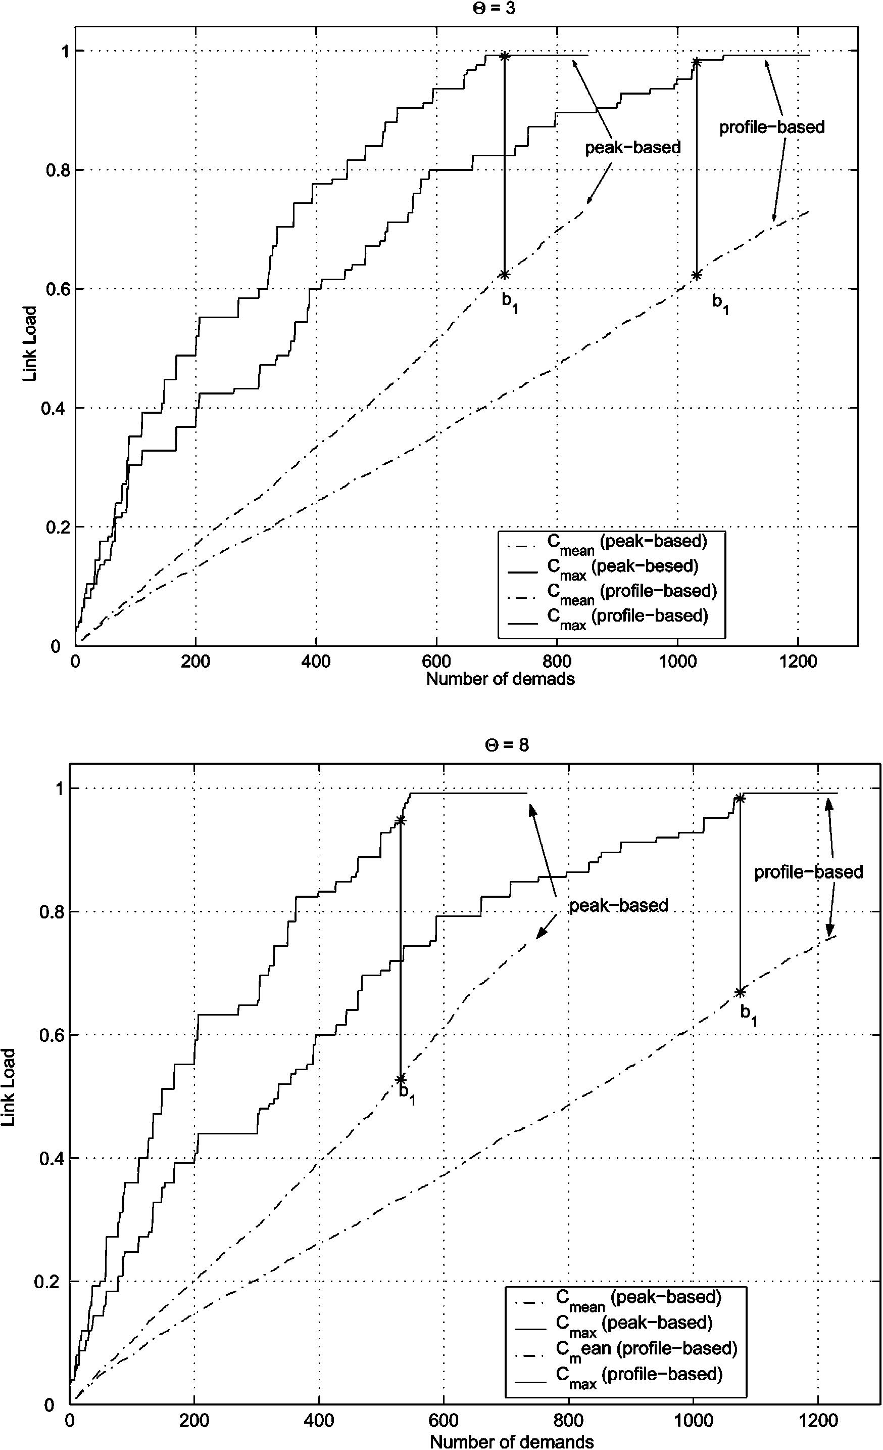

58

F. Ricciato, U. Monaco / Computer Networks 47 (2005) 47–61

function), the only diﬀerence being in the deﬁni-
tion of the residual bandwidth itself. Formally:
C_{m}

by considering the average per-demand bandwidth
consumption for the two schemes. In fact, the
average amount of bandwidth that is reserved by
the peak-based strategy in each time slot is (E(Ж)

w_{m}ј
C_{m} рv_{m}ю f^{k}Ю
ю :
р13Ю
denotes the sample average):

The peak-based on-line algorithm was com-
pared with that proposed in Section 3, referred
here as ‘‘proﬁle-based’’. The comparison was made
for diﬀerent values of time slot granularity, from
H = 2 (12-h slots) to H = 24 (1-h slots). The case
H = 1 was taken as a reference, since in this case
there is no distinction between the two ap-
proaches. Twin experiments were run with peak-
based and proﬁle-based algorithms for the same
input trace. Fig. 5 plots the number of allocated
demands before the 1st, 10th and 100th rejection
(b₁, b₁₀and b₁₀₀), for the 30-nodes network. Each
point is the average over 500 simulations. As ex-
pected the peak-based algorithm is sensibly less
eﬃcient: its allocation power is between 36% and
82% less than the proﬁle-based algorithm.
Furthermore, the performance of the peak-
based strategy become less and less eﬃcient with
increasing number of time slots, while for the pro-
ﬁle-based allocation the performance degradation
is marginal. This was expected and can be easily
explained in the light of the adopted traﬃc model,

Fig. 5. Comparison between ‘‘peak-based’’ and ‘‘proﬁle-based’’
on-line algorithms: number b_{n}of allocated demands before the
nth rejection versus number of time slots H (n = 1, 10, 100,
average over 500 iterations).

E max ff^{k}рsЮg
sј1;...;H
that is increasing with H given that the f^{k}(s) sam-
ples are extracted independently. Instead the pro-
ﬁle-based strategy allocates on average E(f^{k}(s)),
which is independent from H. This is conﬁrmed
by Fig. 6, wherein we compared the growth of

Fig. 6. Comparison between ‘‘peak-based’’ and ‘‘proﬁle-based’’
on-line algorithms: cmean^{and}c_{max}versus number of demands
for H = 3 (top) and H = 8 (bottom).

F. Ricciato, U. Monaco / Computer Networks 47 (2005) 47–61

59

reserved bandwidth (cmean^{and}c_{max}) with the num-
ber of demands for the two algorithms, for two
diﬀerent values of H. The slopes of such curves
roughly represent the average per-demand band-
width consumption. It can be seen that a consider-
able diﬀerence hold between H = 3 and 8 with the
peak-based algorithm. Instead, with the proﬁle-
based approach the variation with H is minimal.
A certain performance degradation of the pro-
ﬁle-based scheme with increasing H was expected,
since an increase in the number of time slots di-
rectly results in a higher variability of the per-de-
mand proﬁle due to the independent extraction
of the f^{k}(s) samples. In turn, this would make
the matching between mutually compensative
demands more problematic. The fact that the ex-
pected degradation is extremely slow (approxi-
mately 6% from H = 2 to 24) is a further
indicator of the power of the proposed algorithm.

6. Discussion on the results

In this section we expand the discussion about
the experimental results reported in Section 5.4,
and relate them with the experimental results of
two previous works [4,5]. The three works refer
to diﬀerent application scenarios: conﬁguration
of a connection-less network [4], conﬁguration of
a connection-oriented multi-layer network
(namely IP over WDM) [5], and on-line routing
in a MPLS network (this paper). Despite such dif-
ferences, all these papers share some fundamental
commonality in the results. In fact, they all con-
sider the problem of network conﬁguration under
the condition that the input traﬃc is variable in
time—with time-of-day periodicity—and known
a priori. Given the diﬀerent application contexts,
the terms ‘‘network conﬁguration’’ and ‘‘input
traﬃc’’ assume diﬀerent meanings. A solution of
network conﬁguration is a set of OSPF/IS-IS link
weights in [4], a logical topology plus a set of
LSP routes in [5], and a set of LSP routes here.
The input traﬃc is a node-to-node traﬃc matrix
in [4], and a set of point-to-point demands in our
works. In all the three works some method was
proposed that explicitly takes into account the
amount of traﬃc at diﬀerent times—assumed

known in advance—to produce a ﬁxed (or static)
network conﬁguration solution that can accom-
modate the traﬃc and its variability. In all the
three works it is found that the goodness of such
a ﬁxed solution is very close to that achievable
with independent optimizations at diﬀerent times
(an approach referred to as ‘‘time-speciﬁc’’ in the
following). More precisely, Fortz and Thorup con-
sidered two diﬀerent traﬃc matrices (night and
day), and found that the quality of their sub-opti-
mal ﬁxed solution is within 10% from the optimal
time-speciﬁc solution. Analogously, in [5] the
authors found a similar distance between the sub-
optimal ﬁxed solution (called JCET therein) and
the best found time-speciﬁc solution (called ICET).
In fact, in that context it was not possible to give a
provable optimality bound because the associated
optimization problem was intrinsically non-relaxa-
ble. Again, in this paper we found that the quality
of the sub-optimal ﬁxed solution (as given by the
on-line heuristic) is very close to the optimal
time-speciﬁc solution (as given by the relaxed oﬀ-
line instance of the variable routing problem).
Additionally, we found that the quality of the opti-
mal ﬁxed solution (as given by the relaxed oﬀ-line
instance of the ﬁxed routing problem) closely
approximates the optimal time-speciﬁc solution.
The similarity between these results is indeed
remarkable, considered that they were obtained
in very diﬀerent application contexts, with diﬀerent
traﬃc models, parameters, topologies, cost func-
tions, etc.
In summary, the common message behind
such works is that in several networking scenar-
ios with variable input traﬃc there is no need
of variable network conﬁgurations, as far as the
traﬃc variations are known in advance or can
be predicted to some extent. We believe that this
is an important contribution of the three works
as a whole, that indicates a promising direction
for further research, with both academical and
practical implications. On the academical side,
further research eﬀorts should be spent in investi-
gating whether there is some more general theo-
retical principle underlying such results, that
can explicate them at a broader level than the
speciﬁc application scenarios in which they were
conceived.

60

F. Ricciato, U. Monaco / Computer Networks 47 (2005) 47–61

7. Conclusions and future work

In this work we proposed a simple on-line algo-
rithm for the ﬁxed routing of demands with varia-
ble bandwidth requirements, to be applied in
virtual-circuit platforms like MPLS. Basically,
the algorithm proposed here is an extension in
the time domain of an existing dynamic shortest-
path approach. We also provided ILP formula-
tions for the associated oﬀ-line problem, both for
ﬁxed and variable routing, and we used them to
obtain reference performance bounds for the on-
line algorithm. The results show that our algo-
rithm is highly eﬃcient and closely approaches
the optimality in terms of bandwidth usage.
Beyond its eﬃciency, an important source of
attractiveness resides in its extreme simplicity, that
makes it suitable to be adapted in more advanced
routing scenarios. For example, considering the
problem of routing fault-protected demands, it
can be straightforwardly incorporated in the mod-
el proposed in [9,10] in order to provide a global
scheme for single and dual fault protection, with
and without bandwidth sharing, in presence of de-
mands with time-varying bandwidth requirements.
This is one of our current working directions.
Based on the proposed scheme, ISPs might ﬁnd
convenient the delivering of more ﬂexible services,
for example time-varying VPN, that better match
the customer needs in terms of bandwidth provi-
sioning timing. Also, from the above considera-
tions ISPs are solicited to monitor and put eﬀorts
in the prediction of the full time-of-day traﬃc pro-
ﬁles (e.g., on a 12- or 8-h time-slot granularity) and
not only of their peaks. In fact, we showed that
with the proposed scheme such full information
can be directly translated into a considerable gain
in resource saving and allocation power.
In a broader perspective, the results presented
here suggest that the a priori knowledge of the
per-demand traﬃc proﬁles can be exploited to
achieve an optimal static routing conﬁguration
which cannot be further improved by dynamic
reconﬁgurations. This lets small room to the use-
fulness of dynamic reconﬁguration schemes pro-
vided that future traﬃc proﬁles are known or can
be predicted in advance. Therefore, the installation
of rerouting functionality into the network for

tracking changes in the traﬃc pattern might be
avoided at all, or at least such mechanisms might
be relegated to handle the unpredictable compo-
nents of the global traﬃc.
Admittedly, our results are limited to the
assumptions made in this work, particularly about
the choice of the traﬃc model. We recognize that a
conclusive quantitative assessment of our scheme
necessitates a topology/traﬃc model more thor-
oughly bound to reality. On the other hand, the
fact that very similar results were obtained in other
works [4,5], carried in diﬀerent contexts and for
diﬀerent topology/traﬃc models is encouraging
about the validity of our conclusions.
We are currently investigating our scheme un-
der diﬀerent traﬃc models, for instance with
non-ﬂat spatial traﬃc distribution. This second
phase of investigations is in a very preliminary
stage. Still, to date we only found further conﬁr-
mations to the ﬁndings reported in this paper.
Our feeling is that the general results reported here
are robust with respect to the choice of the topology/
traﬃc scenario. The veriﬁcation of this statement
needs of course further investigations, but it seems
itself an interesting direction for further research.

References

[1] K. Papagiannaki, N. Taft, Z.L. Zhang, C. Diot, Long-term
forecasting of Internet backbone traﬃc: observations and
initial models, in: IEEE INFOCOM 03, San Francisco,
April 2003.
[2] A. Feldmann, A. Greenberg, C. Lund, N. Reingold, J.
Rexford, F. True, Deriving traﬃc demands for operational
IP networks: methodology and experience, IEEE/ACM
Transactions on Networking 9 (3) (2001) 265–279.
[3] S. Plotkin, Competitive routing on virtual circuits in ATM
networks, IEEE Journal on Selected Areas in Communi-
cations 13 (7) (1995) 1128–1136.
[4] B. Fortz, M. Thorup, Optimizing OSPF/IS-IS weights in a
changing world, IEEE Journal on Selected Areas in
Communications 20 (4) (2002) 756–767.
[5] F. Ricciato, S. Salsano, A. Belmonte, M. Listanti, Oﬀ-line
conﬁguration of a MPLS over WDM network under time-
varying oﬀered traﬃc, in: IEEE INFOCOM 02, New York,
June 2002.
[6] R. Guerin, D. Williams, A. Orda, QoS routing mechanisms
and OSPF extensions, in: Globecom 97, Phoenix, Novem-
ber 1997.
[7] T.V. Lakshman, K. Kar, M. Kodialam, Minimum inter-
ference routing of bandwidth guaranteed tunnels with mpls




F. Ricciato, U. Monaco / Computer Networks 47 (2005) 47–61

61

traﬃc engineering applications, IEEE Journal on Selected
Areas in Communications 18 (12) (2000) 2566–2579.
[8] S. Suri, M. Waldvogel, D. Bauer, P.R. Warkhede, Proﬁle-
based routing and traﬃc engineering, Computer Commu-
nications 26 (2003) 351–365.
[9] F. Ricciato, M. Listanti, S. Salsano, An architecture for
diﬀerentiated protection against single and double faults in
GMPLS, Photonic Network Communications 8 (1) (2004)
119–132.
[10] F. Ricciato, M. Listanti, A. Belmonte, D. Perla, Perform-
ance evaluation of a distributed scheme for protection
against single and double faults for MPLS, in: 2nd Int l
Workshop on Quality of Service in Multiservice IP
Networks (QoS-IP 2003), Milano, February 2003, Lecture
Notes in Computer Science, vol. 2601, Springer, 2003, pp.
218–232.
[11] D. Katz, K. Kompella, D. Yeung, Traﬃc Engineering
Extensions to OSPF Version 2, draft-katz-yeung-ospf-
traﬃc-10.txt, Work in Progress, June 2003.
[12] G. Ellinas, E. Bouillet, R. Ramamurthy, J.F. Labourdette,
S. Chaudhuri, K. Bala, Routing and restoration architec-
tures in mesh optical networks, Optical Networks Maga-
zine 4 (1) (2003) 91–106.
[13] J.B. Orlin, R.K. Ahuja, T.L. Magnanti, Network Flows:
Theory, Algorithms and Applications, Prentice Hall,
Englewood Cliﬀs, NJ, 1993.
[14] <www.ampl.com>.
[15] <www.ilog.com>.
[16] R.R. Iraschko, M.H. MacGregor, W.D. Grover, Optimal
capacity placement for path restoration in STM or ATM
mesh-survivable networks, IEEE/ACM Transactions on
Networking 6 (3) (1998) 325336.
[17] S. Bhattacharyya, C. Diot, J. Jetcheva, N. Taft, Pop-level
and access-link- level traﬃc dynamic in a tier-1 POP, in:
Proc. of ACM SIGCOMM Internet Measurement Work-
shop (IMW 2001), San Francisco, November 2001.

[18] Z. Wang, J. Crowcroft, Quality-of-service routing for
supporting multimedia applications, IEEE Journal on
Selected Areas in Communications 14 (7) (1996) 1228–
1234.
[19] G. Apostolopolous et al., QoS routing mechanisms and
OSPF extensions, in: RFC 2676, August 1999.

Fabio Ricciato received his ‘‘Laurea’’
degree in Electronics Engineering in
1999 and his ‘‘Dottorato di Ricerca’’
(Ph.D. degree) in Information and
Communications Engineering in 2003,
both from the University of Roma ‘‘La
Sapienza’’. Since November 2002, he is
a research fellow in the Networking
group of the INFOCOM Department.
During 2000–2003, he collaborated
with CoRiTeL (a research consortium
sponsored by Ericsson Italy) and par-
ticipated to the European research
project called AQUILA. His research interests include trans-
port networks technologies (IP, MPLS, Optics) and related
topics (QoS, routing, traﬃc engineering, fault protection, net-
work planning, GMPLS).

Ugo Monaco received his ‘‘Laurea’’
degree in Electronics Engineering in
2002 from the University of Roma ‘‘La
Sapienza’’ of Rome, Italy. He is Ph.D.
student in the same university. His
research interest include MPLS rout-
ing and traﬃc engineering.

